DEENDAYAL PORT AUTHORITY
An ISO 9001:2008 & ISO 14001:2004 Certified Port

Mobile: 9825227048 Office of the Executive Engineer (E)
Mail: xenedpa@gmail.com Ground Floor, Nirman Building, New Kandla – Kachchh,

No.: EL/WK/ Date: 11/11/2025.

EXPRESSION OF INTEREST

EXPRESSION OF INTEREST [EOI] for “Upgradation of power supply for power plug point at SNA & Flotilla jetty & providing HT power supply to Green Tug.”.”
(This Notice is issued only to elicit Expression of Interest from the parties interested in the work and does not constitute any binding commitment from the Deendayal Port Authority to proceed with the work or invite any or all the parties in the subsequent bidding process. The Open Tenders will be issued subsequently.)
Executive Engineer (Electrical), DPA invites Expression of Interest for the work of “Upgradation of power supply for power plug point at SNA & Flotilla jetty & providing HT power supply to Green Tug” from the reputed firms from those who have executed similar work in Government/public sectors and other leading private organizations. The Expression of Interest (EOI) documents containing details of Scope of Work and Technical Specifications are enclosed herewith.
The interested firms are requested to submit their expression of interest for the said work in BOQ format as enclosed at Annexure I. The completed EOI (Expression of Interest) shall be submitted to the office of the undersigned on or before 27/11/2025. A soft copy of EOI is also

Yours faithfully

-- sd--
Executive Engineer (Electrical)
Deendayal Port Authority

“Schedule B”
Sr. No. | Description of Items | Qty | Rate | Unit | Amount
1 | - Supply at Site following type of 11/0.433 KV, Package Substations with fault level of 21KA for 1 sec having dry type transformer of 500VA and as per Tech. Spec No. 1(a).  - Installation, testing & Commissioning of 11/0.433 KV Compact Substation and as per Tech. Spec No. 1(b) | 1  1 |  | No.  No
2 | - Supply of following type 12 KV, 630Amps, 21KA motor operated SF 6 Gas insulated IP 67 degree of protection, IP 54 Class outdoor type with both side extensible Ring Main Unit complete along with, Motorized with battery and battery charger etc. as per tech spec no 1(a).  - 6way RMU (2 Incomer + 4 outgoing).  - 4 Way RMU (1 Incomer + 3 outgoing).  - Installation, testing & Commissioning of 12KV,630Amps 21KA Outdoor mounted RMU Unit over pedestal platform as per Technical Specification No. 1(b).  - 6 way RMU (2 Incomer + 4 outgoing ).  - 6 way RMU (1 Incomer + 3 outgoing). | 1  1  1  1 |  | No  No  No  No
3 | Supply, of 3Ph, 4 wire Tri Vector Energy Meter for HT O/g with DLMS protocol of accuracy class 0.2s, with Metering Panel as per technical Specification no 3. | 1 |  | No.
4 | Installation, testing & Commissioning of 3Ph, 4 wire Tri Vector Energy Meter for H.T O/g on the pedestal Stand as per technical Specification no 4. | 1 |  | No.
5 | Supply at site following type of Heat shrink Straight through joint Kit & end termination kit for 3 core, 300 Sq. mm size 11kV XLPE aluminum cable as per Technical Specification No. 5.  - Outdoor / indoor type  - Straight through joint type | 10  20 |  | No  No
6 | Supply at site H.T, (U/E) XLPE Insulated11kV grade armored cable with aluminum conductor. The cable shall be complied with requirement of IS:7098 (Part-II) with up to date amendment and asper Technical Specification No.- 6.  - 3 C X 185 sq.mm Insulated11kV grade  - 3 C X 300 sq.mm Insulated11kV grade | 1500  6000 |  | Mtrs.  Mtrs.
7. | Laying, Testing & Commissioning of 11KV grade HT XLPE cable of size up to 3C x 400 Sqm as per following Technical Specification no.7 mentioned under  Laying of Cable  - Through RCC Cable Trench as per technical Specification no 7(a ).  - laying of cable through exaction in all type of Soil as per technical specification no 7(b ).  - Laying of cable in half round RCC pipe of 6" internal dia as per technical speci no 7(C) .  - Laying of cable through RCC Jetty / RCC surface excavation through RCC cutter /pneumatic breaker with HDPE / GI pipe of suitable for laying 3c x 150Sqmm XLPE cable as per technical Specification no 7(d).  - Laying of Cable through horizontal boring (16”) in RCC Road /Rail/Jetty/RCC surface by providing HDPE pipe of suitable size as per technical Specification no 7(e) | 4000.  500  500  200  2300 |  | Mtrs.  Mtrs.  Mtrs.  Mtrs.  Mtrs.
8  a)  b)  c)  d)  e) | Supply at Site 1.1KV grade LT XLPE Cable steel armored aluminum conductor cable, Cross linked Polyethylene (XLPE),FRLS, insulated, PVC sheathed, armoured power cables for effectively earthed systems of approved make and manufacturer as per relevant IS and as per Tech Specification No. :-08  4C x 240 Sq. mm  4C x 120 Sq. mm  4C x 95 Sq mm.  4C x 70 Sq mm.  4C x 35Sq mm | 500  300  700  1000  800 |  | Mtrs.  Mtrs.  Mtrs.  Mtrs  Mtrs
9 | Laying of 3.5/4.0 Core LT armored aluminum conductor XLPE cable of 1.1KV grade of the following type as per as per technical Specification no 9  - Laying of cable in RCC trench as per technical Specification no 9(a)  - laying of cable through exaction in all type of Soil as per technical specification no 9(b ).  - Laying of cable on Wall / Truss / Structure as per technical Specification no 9(b).  - Laying of cable in half round RCC pipe of 6" internal dia as per technical speci no 9(c ).  - Laying of Cable through horizontal boring (16”) in RCC Road /Rail/Jetty/RCC surface by providing HDPE pipe of suitable size as per technical speci no 9(d ). | 1200  500  500  200  500 |  | Mtrs  Mtrs  Mtrs  Mtrs  Mtrs
10 | Supply of Hot dip Galvanized perforated type cable tray complete with coupler plates, fasteners, clamps and fixing hardware’s etc as per technical spec no. 10  a) Cable tray 2 MM thick- perforated type  -50mm x 25 mm x 2.5mtr.  b) Cable tray 2 MM thick- perforated type  -100mm x 25 mm x 2.5mtr | 150  250 |  | Mtrs  Mtrs
11 | Fixing of Hot dip Galvanized perforated type as per technical specification no. 11. | 400 |  | Mtr
12 | Supply of 18 Way 415V, outdoor mounted L.T Distribution Panel in existing craft jetty replacing the old LT panel as per technical specification no. 12. | 1 |  | No
13 | Installation, testing and commissioning of 18way LT Distribution Panel at existing site after altering / removing the old panel at inside the substation as per technical specification no.13. | 1 |  | No
14 | Supply of dust and vermin proof pedestal type main distribution panel for distribution power supply to Power Plug point installed at Tug & Flotilla Jetty as per Technical Specification no:-14 | 3 |  | No
15 | Supply of dust and vermin Proof out door pedestal type Power plug panel for providing power to individual tugs & craft installed at tug and flotilla jetty as per Technical Specification no:-15 | 20 |  | No
16 | Installation, testing and commissioning of Distribution Panel, Plug Point Power Panels as pert technical Specification no 16 | 23 |  | No
17 | Supply, Installation, testing & commissioning of Maintenance free Earthing system comprising of 25 mm dia. 3 mtr long earthing electrode of low carbon steel electrode with 250 microns copper coating + carbon based conductive back fill compound & copper Cl strip on DTC of 25 x 6 mm with termination on panel interlocking with existing earthing system etc and as per technical specification no 17. | 30 |  | Cop Job
18 | Supply, Laying, connecting of Copper / G.I strip as per technical Specification no 18  - Copper Strip of size 50 X 6 mm.  - G. I Strip of Size 40 x 6 mm | 200  525 |  | Mtr  Mtr
19 | Supply, Laying, connecting of GI Wire Connecting earth station to the equipment as per Technical Specification No 19 | 200 |  | Mtr
TOTAL
(In words Rupees _____________________________________________________________________________-_______________________________________________________________________ only)
(NOTE: The rates should be inclusive of all taxes, duties, fees, cess etc and all incidental charges; but exclusive of GST)

--SD--
Signature & Seal of Contractor Executive Engineer (E)
Deendayal Port Trust

Name of Work :- Upgradation of power supply for power plug point at SNA & Flotilla jetty & providing HT power supply to Green Tug

SECTION 4

TECHNICAL SPECIFICATIONS & SCOPE OF WORK

- GENERAL:

  - All equipment and material shall be designed manufactured and tested in accordance with the latest applicable IEC standard.

  - Equipment and material conforming to any other standard, which ensures equal or better quality, may be accepted. In such case copies of English version of the standard adopted shall be submitted.

  - The electrical installation shall meet the requirement of Indian Electricity Rules- 1956 as amended up to date; relevant IS code of practice and Indian Electricity Act-1910. In addition other rules and regulations applicable to the work shall be followed. In case any discrepancy, the most stringent and restrictive one shall be binding.

  - The high-tension switchgear offered shall in general comply with the latest issues including amendments of the following standards but not restricted to them.

- Scope of Work:-
The scope of work comprises of the following:

  - The work involves providing 3 Phase un- interrupted power supply to Tug and craft at SNA & Tug jetty from individual plug point erected on the wharf area under green revolution.

  - The work includes supply at site, Installation, testing & Commissioning of Compact Sub Station, Ring Main units’ outdoor type SF6 filled, with various combinations of load break isolators & breakers. with associated equipment including civil work,

  - The RMUS should be Modular, extensible type on both sides with provision of attaching/connecting with SNAP FIT arrangement W/o External Busbars additional load break switches and circuit breakers in future whenever required. However, RMU shall be extensible on both side however left side is occupied by metering panel and right side is free for extension on vice versa is also possible depending on site condition. Alternatively Extension shall be possible by adding trunking chambers and required accessories or by plug-in bushing type arrangement.
  - Configurations Required:-
11KV RMU
- 6-way -11KV Gas (SF6) Insulated RMU with 6Nos SF6 Insulated VCB of suitable rating –out of which 4 outgoing feeder & 2 nos incoming feeder.
- 4-way -11KV Gas (SF6) Insulated RMU with 6Nos SF6 Insulated VCB of suitable rating –out of which 2 outgoing feeder & 2 nos incoming feeder.

  - Supply, Erection/ Installation Testing & Commissioning of for L.T power supply to tower and non- residential building on SNA & Tug jetty

  - Supply, Laying & end termination of HT, 11 KV XLPE (E) armoured cable with aluminium conductor of size 3 C X 150 sq.mm form two different source one from port power house & second source from Cargo jetty substation to RMU unit & Compact Substation & one independent source from cargo jetty substation to Port power house of 3C x 300Sq mm in the newly constructed RCC trench line

  - Supply, Laying & end termination of 3C x 185 sq. mm & 3C x 300 Sq mm HT, 11 KV XLPE (E) armoured cable with aluminium conductor with ISI mark confirming to IS:7098 (Part-II) 1985 with up-to-date amendments and of approved make.

  - Earthing system for the entire work.

1.6 After successful completion of whole work in all respect to carry out testing and commissioning of the complete work to the entire satisfaction of Deendayal Port Authority.

  - The broad details of each item of the work are shown in the Schedule “B” attached herewith.

  - The Compact Substation designed shall confirm the following standard technical requirements. The Insulation values shall be enhanced considering the altitude of operation & Site atmospheric conditions.

SITE INFORMATION:
a. CLIMATIC CONDITIONS
The climate at Kandla is hot, humid, dusty and salt laden, conducive to rust. During summer, the temperature varies from 25 C to 44 C and in winter, which is mild from 10 C to 25 C. Kandla falls under scanty rainfall zone.
b. AIR TEMPERATURE
The minimum ambient air temperature at Kandla is 10C and the maximum ambient air temperatures observed are 45C (Outdoor) and 40C (Indoor).
c. WIND PRESSURE
Wind velocity of 25 to 60 Kmph is common on any day, specially during summer (March to September). The maximum wind velocity recorded is 180 to 200 Kmph. The direction and the average wind speed observed are as under

Period | Direction | Average Speed
* October – March | North – East | 10 Kmph
* April – May | South – East | 20 Kmph
*June– September | South – West }  North – East } | 60 Kmph

d. SEISMIC FORCE
Kandla falls under Seismic Zone No – V, as per IS:1893.
e. RAINFALL
Rainfall in Kandla is very low, Between January and April, there is normally no rainfall. Rainfall mainly remains confined between June and August. During the remaining months, the rainfall is scanty. The average annual rainfall is around 200 mm only. However, there have been years when the rainfall was heavier, though such occasions are not common.
- RELATIVE HUMIDITY.
The relative humidity at Kandla is of the order of about 70 %.
TECHNICAL SPECIFICATIONS

1(a) TECHNICAL SPECIFICATIONS FOR ITEM NO. 1(a)

INTENT OF SPECIFICATION
This specification is intended to cover the design, manufacture, assembly, testing at manufacturer's works, supply & delivery, properly packed for transport of the Packaged Substation(PSS)/Compact Substation(CSS), 11kV Ring Main Unit (RMU) and supervision of erection & commissioning as specified herein under, complete with all accessories, fittings and auxiliary equipment as required for efficient & trouble-free operation. The packaged(PSS)/Compact substation shall be suitable for installation and operation near the sea front.

CODES & STANDARDS:
  - All equipment and material shall be designed manufactured and tested in accordance with the latest applicable IEC standards.
  - The Package Sub-station offered shall in general comply with the latest issues including amendments of the following standards.
Title | Standards
High Voltage Low Voltage Pre-Fabricated Substation | IEC:61330/62271-202
High Voltage Switches | IEC 60265
Metal Enclosed High Voltage Switchgear | IEC 60298/62271-200
High Voltage Switchgear | IEC 60694/62271-100
Low Voltage Switchgear and Control gear | IEC 60439/60947
Power Transformers | IEC 60076

SCOPE & SPECIFIC REQUIREMENTS
  - Supply of 1 nos. 500kVA, 11kV, Package Substations with fault level of 21KA for 1 sec. Following equipment details part of each Package substation.

S. No | Description
i) | 11kV RMU: Quantity:1 no.  Four way 11KV Non-Extensible Ring Main Unit Compact switchgear consisting of 630A two numbers SF6 insulated fixed manual fault making / Load break Switches /SF6 insulated Vacuum circuit breaker & 630A one number of Fixed manual SF6 insulated Vacuum circuit breaker. SF6 insulated Vacuum circuit breakers with self- powered relay having Transformer protection, over current and earth fault protection. Interconnection between RMU and transformer shall be by using suitable Copper un-armoured 11KV (UE) 1CX1RX150 sq.mm per phase cable which is in the scope of Bidder. Incomer break switches shall be suitable for termination of 2 runs of 3C X 240 Sq.mm aluminium armoured XLPE Cable

 | Make of RMU switchgear: ABB/ Siemens/ Alstom / Schneider/L&T make only.
 | Make of relay to be used with VCB: L&T/ABB / Areva / Siemens / Schneider make only
Transformer Feeder Metering
3 Nos 11KV Single core Ring type metering CTs with 40/5A or 50/5A for each transformer feeder.
ii) | 500 kVA 11kV/0.433KV Dry type Transformer: Quantity: 1 No.
  a) | Transformer capacity | 500 KVA (DRY TYPE)
  b) | Primary voltage | 11 KV +/- 10%
  c) | Frequency | 50 HZ
  d) | No. of Phases | 3
  e) | Insulation Class | ‘F’
  f) | Cooling | Natural Air
  g) | Temperature | Max 115 C by RTD
  h) | Percentage Rise | As per IS
  i) | In winding | 90 degree C
  j) | Winding connection | Star/Delta
  k) | Impedance | As per IS/BIS/DIN
  l) | Vector Group | Dyn 11
  m) | Neutral Grounding | HV ungrounded  LV Solidly Grounded
  n) | Winding material | Copper
  o) | Noise Level | As per IEEE 141
  p) | Vibration Level | 3 G (min.)
  q) | Painting | 632 Shed of IS:5 or BIS/DIN Standard
  r) | Tapping Range | +/- 5%
  s) | Losses | Maintain as per IS/BIS/DIN
  t) | Make | Siemens/Crompton/BHEL/Schneider
 | Make of the transformer: Should be same as CSS.
 | Impedance, no-load/ load losses, efficiency, temperature rise above ambient of winding of the transformer should be as per IS/IEC/CBIP standards.
 | Suitable surge arrestor shall be provided between VCB & Transformer
iii) | LV Switchgear: (Inside CSS) Quantity:  1 No: 800A ACB Incomer  1 No: 800A MCCB outgoing feeder 1 No. 200A MCCB Outgoing Feeder 1 No.100A MCCB Outgoing feeders  415V indoor LV panel with Aluminum Bus bars, fabricated using CRCA sheet steel, Ingress Protection IP4X, compartmentalized complete with internal wiring consisting of following.  Incomer: 800 A, TPN, 415V, 3P, 50Hz, 21KA, fixed manual type ACB with Microprocessor based O/L, S/C, and E/F (IDMTL+Inst.) release.  Rated Insulation Voltage Ui = 1000V, Utilization category = B  LT Switchgear should be suitable for termination of 2run X 3 ½ C X 240 Sq.mm aluminum armored Cable.
 | Make of the ACB - L&T/ Siemens / GE/ABB/ Schneider /Areva make only.

LV Switchgear : Metering (for Incomer)
Maximum demand controller as per the specification at pg no:22 shall be provided (Conzerv/L&T/Secure/Schneider/elmeasure) – 1 No. Controller shall be suitable to trip the MCCBs as per the settings.
LT Metering CT’s – 3 Nos, 800/5A, Cast Resin Type, Cl – 1.0, R, Y, B, ON, OFF,TRIP LED Indicating Lamps - 6 Nos.
(MakeTechnic/Vaishno/STS/Rep.) Control MCB, 6A, SP - As required
iii | LV Switchgear : Outgoing (Inside CSS)  800A,200A and 100 A,TPN ,415V, 3P, 50Hz, 21KA, Fixed manual type MCCB with Microprocessor based O/L,S/C & E/F release and trip contacts suitable for  Digital Multifunction Meter with A,V,KW,KWH,PF, Cl-0.5 with RS 485 Port (Conzerv/L&T/Secure/Schneider) for each outgoing feeder  LT Metering CT’s, Cast Resin Type, 100/1A, Cl-0.5 (Matrix/AE/G&M Make). Control MCB, 6A, 4P-As required (MDS/L&T/GE/SCHNEIDER/ABB)  Outgoing MCCBs of LT Switchgear should be suitable for termination of 1run X 4 C X 300 Sq.mm aluminum armoured Cable.  800A outgoing MCCB must be suitable for termination of 3 runsX 4 CX 300 Sq mm Al armoured cable.  Make of the MCCB - L&T/Siemens/GE/ABB/ Schneider /Areva make only.
iv | Enclosure: Quantity:1 No.  Outdoor type enclosure having modular construction of Galvanized Sheet Steel. The degree of protection for HT & LT switchgear compartment shall be IP55 & degree of protection of transformer compartment of the enclosure shall be minimum IP23.  Painting of the enclosure exterior shall be suitable for sea shore conditions. Each compartment will be provided with the door and pad locking arrangement. The Compartment illumination lamp with door-operated switch shall be provided for each compartment. Structure of the substation shall be able to withstand the gross weight of all equipment. It should be possible to transport the equipment along with transformer, RMU & LT Panel from one site to another. This shall be installed at sea front, hence, accordingly design parameters to be taken into account.
v | Interconnection between HT switchgear & Transformer using XLPE cable & Interconnection between Transformer & LT switchgear using high conductivity Aluminium busbars(E91E) . Internal earthing connections by GI strips.
vi | DC supply for PSS shall be through in built 24V power pack. Separate DC supply shall be not provided for auxiliary power requirement purpose.
vii | All power cables except 3Rx1Cx95 Sq.mm Cu (Between VCB and Transformer H.T) will be by BHEL.
  - Supply of 1 no. 11kV, Ring Main Unit with fault level of 21KA for 1 sec. Following equipment details part of 11kV RMU.
S. No | Description
i) | 11kV RMU: Quantity:1 no.  CCC NE with three way Motorized Outdoor Ring Main Unit consisting of three numbers  630A SF6 insulated fixed motorized fault making / Load break Switch and earth switch. The RMU shall be suitable for installation at Sea shore.
Enclosure: Quantity: 1 No.
Outdoor type enclosure having modular construction of Galvanized Sheet Steel. The degree of protection shall be IP55.The painting of the enclosure exterior shall be suitable for sea shore conditions. Each compartment will be provided with the door and pad locking arrangement. The Compartment illumination lamp with door-operated switch shall be provided for each compartment. Structure of the substation shall be able to withstand the gross weight of all equipment.
 | DC supply for RMU shall be through in built 24V power pack. Separate DC supply shall be not provided for auxiliary power requirement purpose.
  - All necessary foundation bolts and accessories are in the scope of Bidder.
  - Supply of commissioning spares as per Annexure 3 .
  - Supervision of installation, testing & commissioning of 11kV CSS & 11kV RMU is in the scope of Bidder.

Design Criteria
  - Package Sub-station consisting of 3 way 11KV SF6 insulated Switchgear with 630A 2no. of LBS +1 no. of 630A 11KV vacuum Circuit Breaker + 11kV/415V, 500KVA, DYn11 Transformer + LT 415V, 800A ACB incoming with all connection, accessories, fitting & auxiliary equipment in an enclosure to supply Low-voltage energy from high-voltage system and 11kV RMU as detailed in this specification. The complete unit shall be installed on a substation plinth (base) as Outdoor substation.

  - The prefabricated-package substation shall be designed for
a) Compactness,
b) fast installation,
c) maintenance free operation,
d) safety for worker/operator & public .

  - The Switchgear and component thereof shall be capable of withstanding the mechanical and thermal stresses of short circuit listed in ratings and requirements clause without any damage or deterioration of the materials.

  - For continuous operation at specified ratings temperature rise of the various switchgear components shall be limited to permissible values stipulated in the relevant standard and / or this specification.

  - Service Conditions:
The Package substation shall be suitable for continuous operation under the basic service conditions indicated below
Ambient Temperature: 50 Deg C Relative Humidity upto 95% Altitude of Installation upto 1000m

The Enclosure of High Voltage switchgear-control gear, Low Voltage switchgear-control gear & Transformer of the package substation shall be designed for use at sea shore. The enclosure should take minimum space for the installation including the space required for approaching various doors & equipment inside.

DESIGN REQUIREMNT OF 11kV CSS & 11kV RMU
The main components of a prefabricated package substation are Transformer, High- voltage switchgear-control gear, Low-voltage switchgear-control gear and corresponding interconnections (cable, flexible bus bars) & auxiliary equipment and 11kV RMU. The components shall be enclosed, by either common enclosure or by an assembly of enclosure. All the components shall comply with their relevant IEC standards.

OUTDOOR ENCLOSURE:
    - The enclosure shall be made of 2.0mm thickness galvanized Sheet Steel tropicalized to local weather conditions including all partition sheets and doors. The out door enclosure wall of the USS are designed in a corrugated wall type design for robust construction and heat dissipation. The base of enclosure shall be 4mm thick Hot dip Galvanized sheet steel.
    - The metal base shall ensure rigidity for easy transport & installation.
    - The protection degree of the Enclosure shall be IP55 for LT & HT switchgear compartment & IP23 for Transformer compartment. Proper / adequate ventilation aperture shall be provided for natural ventilation by way of Louvers etc.
    - IP 55 for 11kV RMU.
    - The doors shall be provided with proper interlocking arrangement for safety of operator.
    - The H.V. & L.V. outgoing of the transformer are to be connected to Vacuum Circuit Breaker of 3 way 11kV RMU & incomer of the Low Voltage Switchgear by means of Aluminum Cables / Flexible Busbars.
    - Internal Fault: Failure within the package substation & 11kV RMU due either to a defect, an exceptional service condition or mal-operation may initiate an internal arc. Such an event may lead to the risk of injury, if persons are present. It is desirable that the highest practicable degree of protection to persons shall be provided. The Design for Internal arc fault shall be tested for 20KA for 0.1sec as per IEC 61330/62271-200.
    - Covers & Doors: Covers & doors are part of the enclosure. When they are closed, they shall provide the degree of protection specified for the enclosure. Ventilation openings shall be so arranged or shielded that same degree of protection as specified for enclosure is obtained. Additional wire mesh may be used with proper Danger board for safety of the operator. All covers, doors or roof shall be provided with locking facility or it shall not be possible to open or remove them before doors used for normal operation have been opened. The doors shall open outward at an angle of at least 90⁰ & be equipped with a device able to maintain them in an open position.
    - Earthing: All metallic components shall be earthed to a common earthing point. It shall be terminated by an adequate terminal intended for connection to the earth system of the installation, by way of flexible jumpers/strips & Lug arrangement. The continuity of the earth system shall be ensured taking into account the thermal & mechanical stresses caused by the current it may have to carry. The components to be connected to the earth system shall include:
      - The enclosure of Package substation,
      - The enclosure of High voltage switchgear & control gear from the terminal provided for the purpose,
      - The metal screen & the high voltage cable earth conductor,
      - The transformer tank or metal frame of transformer,
      - The frame &/or enclosure of low voltage switchgear,
    - There shall be an arrangement for internal lighting activated by associated switch for HV, Transformer & LV compartments separately.
    - Labels: Labels for warning, manufacturer’s operating instructions etc. shall be durable & clearly legible.
    - Cleaning & Painting:
The paints shall be carefully selected to withstand sea shore conditions. The paint shall not scale off or crinkle or be removed by abrasion due to normal handling.

11KV SF6 Non-extensible RMU Circuit Breaker:
    - 11KV SF6 RMU Circuit Breaker: The requirement of 11kV Ring Main Unit SF6 Gas filled comprising of 3 panels as indicated below is as under.
    - Panel No.1 & 2: Manual operated Load break switch with integral earth switch having full making capacity shall be used for Incoming / outgoing cables.
    - Panel No. 3: Vacuum Circuit Breaker complete with operating mechanism, protection system for transformer and cable box.
    - 11kV RMU shall be provided with CCC NE with three way Motorized outdoor Ring Main Unit consisting of three numbers 630A SF6 insulated fixed motorized fault making / Load break Switch and earth switch
    - The above breakers, Busbars should be mounted inside a robotically welded sealed for life, stainless steel tank. The tank should be filled with SF6 gas at adequate pressure.
    - The Circuit Breaker is required to control 11kV/415 volts distribution Transformer of rating 500KVA and relay settings shall be selected accordingly.
    - General Finish: Totally enclosed, metal clad, vermin and dust proof suitable for tropical climate use as detailed in the specification.
    - Ratings: The busbars shall have continuous rating of 800 Amps. Circuit Breaker shall have a continuous rating of 800 Amps. in accordance with relevant IEC standard
    - Breaking & Making Capacity: Circuit Breaker shall be capable of having rupturing capacity of 20kA symmetrical at 11KV.
    - Busbars: Switchgear shall be complete with all connections, busbars etc. The continuous rating of copper bus bars shall be 630 Amps and they shall be fully encapsulated by SF6 gas inside the steel tank. Busbar should be rated to withstand dynamic and thermal stresses for full length of switchgear.
    - Cable switch: It should be switch-disconector and earthing switch using SF6/VCB gas as on arc-quenching medium. The switch position are closed-open-earthed. In open position switch satisfies the disconnector requirement.
    - Earth Switch: Earth switch should be rated equal to switchgear rating. Earth switch should be quick make type capable of making rated fault current. Earth switch should be operated from front of the cubicle.
    - The Mechanism: All the mechanism should be situated in the mechanism compartment behind the front covers outside SF6 tank. Mechanism for switch and earth switch is operating both the switches via one common shaft.
    - Front covers: Front covers contains the mimic diagram of the main circuit with the position indicator for the switching devices. The voltage indicator should be situated in front covers. Access to the cable bushing in the lower part of each module.
    - Position Indicator: Position indicator are visible through the front covers and are directly linked the operating shafts of switch devices.
    - Voltage indicator: Voltage indicator situated in front covers, one of each module and indicate the voltage condition of each incoming cable. Identification of phase is achieved through labels L1,L2, and L3 on the front of the voltage indicator. Voltage indicator should complies requirement of IEC61243.
    - Cable Compartment: It should be possible terminate the cables as specified in the specification. The access to the compartment shall be possible by removing the cable cover and bolted to the main frame. Removable steel covers close the cable compartment. Arc proof cable covers should be available. Each module should have separate compartment that is segregated from each other by means of partition wall. A partition wall should be fitted to divide the cable compartment from the rear side of the switchgear. In case arc inside the tank, followed by opening of pressure relief device the partition wall prevent the hot gases flowing out from the pressure relief to enter the cable compartment.
    - Power Connection: The cable are installed in the dedicated compartment below the mimic front cover. At bottom of cable compartment, an earthing bar system made of copper with a minimum cross section area of 120 sq.mm should be fitted. In each compartment the earthing bar should be fitted with 4 screws M10.The earthing system is connected to the tank by copper bar which rises upto the connecting point of the tank behind the rear portion wall on the middle of the switchgear.
    - Fault passage Indicator: Each RMU should be equipped with display phase current of feeder circuit. Each RMU should be provided with fault passage indicator to on isolator to indicate earth fault. This facilitate quick detection of fault section of line the unit shall be self contained requiring no auxiliary power and shall be integral part of RMU to avoid thefts. The fault shall be displayed by LED/flag indication with three options for reset. (Manual/on restoration of supply/Settable time

Switchgear:
The SF6 RMU shall be sealed for life, the enclosure shall meet the “sealed pressure system” criteria in accordance with IEC: 298. There shall be no requirement to ‘top up’ the SF6 gas. It shall provide full insulation, making the switchgear insensitive to the environment. Thus assembled, the active parts of the switchgear unit shall be maintenance free.
The switchgear & switchboard shall be designed so that the position of different devices is visible to the operator on the front of the switchboard & operations are visible as well. The switchboard shall be designed so as to prevent access to all live parts during operation without the use of tools.
RMU should be tested for internal arc fault test.

Isolator (Load Break Switch):
The Isolators offered shall conform to IS: 4710/9920 as amended to date. The isolator shall be ON Load type, triple pole, spring assisted, hand/motorized operated, non-automatic type with quick break contacts and fault indication. The operating handle shall have three positions ‘ON’, ‘OFF’ and ‘EARTH’ which shall be clearly marked with suitable arrangement to padlock in any position. A safety arrangement for locking shall be provided which shall prevent from the isolator operation ‘ON’ position to ‘EARTH’ position or vice versa.

Vacuum Circuit Breaker:
The Unit shall consist 630A Tee-off spring assisted three position, three pole circuit breaker, with integral fault making / dead breaking earth switch. The function shall be naturally interlocked to prevent the main & earth switch from being switched ‘ON’ at the same time & the CB not allowed to trip in ‘Earth On’position. The selection of the main/earth switch lever on the panel, which is allowed to move only if the main or earth switches in the off position. The lever shall be able to pad locked in either the main or earth position.
The manual operation of the circuit breaker shall not have an effect on the trip spring. This should only be discharged under a fault (electrical) trip condition; the following manual reset operation should recharge the trip spring & reset the CB mechanism in ‘main off’ position.

Air Circuit Breaker:
The Unit shall consist 630A Tee-off spring assisted three position, three pole circuit breaker, with integral fault making / dead breaking earth switch. The function shall be naturally interlocked to prevent the main & earth switch from being switched ‘ON’ at the same time & the CB not allowed to trip in ‘Earth On’ position. The selection of the main/earth switch lever on the panel, which is allowed to move only if the main or earth switches in the off position. The lever shall be able to pad locked in either the main or earth position.
The manual operation of the circuit breaker shall not have an effect on the trip spring. This should only be discharged under a fault (electrical) trip condition; the following manual reset operation should recharge the trip spring & reset the CB mechanism in ‘main off’ position.

Protection Relay:
The CB shall be fitted with self-powered relay inside the front cover to avoid any tampering. The relay should be 3 Over Current + 1 Earth Fault, fed by protection CTs mounted in the cable box.

Cable Box:
Every VCB shall be provided with suitable and identical cable boxes in front for connecting 3 core X 50 Sq.mm, 11kV cable from vertically below. The cable boxes shall be so located at convenient height to facilitate easy cable jointing work. The height available for cable termination should be minimum 500 mm. The Cable termination shall be done by Heat shrinkable Termination method so adequate clearances shall be maintained between phases for Termination. It shall be possible to terminate 2 runs of 3 Core X 50 sq.mm or 1 run of 1 core X 300 Sq.mm XLPE cable.

Locking Arrangement:
Suitable padlocking arrangements shall be provided as stated below.
      - CB manual operating handle in the “OFF” position.
      - Each feeder Panel operating handle in ‘Closed’ ‘Open” or ‘Earth’ position.

General Requirements:
  - Compact Sub-Station & RMU shall be outdoor plinth mounted type.
  - Erection, Commissioning and Civil work for package substation & RMU is in the scope of BHEL. However, Supervision of erection, testing and commissioning is in the scope of Bidder. Further, the Vendor shall furnish the foundation details & foundation bolts & accessories.
  - Package sub-station & RMU will be complete with the internal interconnections & earthing (GI) and extending of earth bar of Neutral and body terminals to the frame of the CSS for connecting to the earth pits. External earthing from CSS frame to earth pit is in the scope of BHEL.
  - Vendor shall assemble the Compact substation & RMU at factory and no assembly of the same shall be allowed at site.
  - Required technical data sheet of the transformer, HV/ MV switchgear, relay etc. should be furnished with the offer.
  - Colour of paint to be mentioned in the offer and to be decided mutually. Tentative paint shade shall be RAL-7032.
  - The CSS & RMU shall be should be SCADA compatible.
  - Vendor shall supply suitable & required no. of HT & LT Cable termination kits along with CSS for HT & LT Cable terminations.

Pre-Dispatch Inspection:
Vendor shall offer for pre-dispatch inspection at vendor’s works. Only after the equipment’s are cleared by DPA in writing, the vendor can dispatch the equipment. Routine tests to be conducted and original test certificates to be submitted at the time of PDI.

Commissioning Spares & Tool and Tackles:
The following additional commissioning spares required – Digital Multifunction Meter- 1No; MCB(each type & rating)- 5Nos. ; Indicating Lamps(Each Color) -10Nos ; 11KV,3.15A
H.T fuse(each type & rating) – 2No ; Spring Charging handles-2 Nos ;Panel Keys – 2 Nos; Control fuses (each type & rating) – 5Nos.
- Typical SLD’s
(A) Typical SLD of 500KVA CSS::

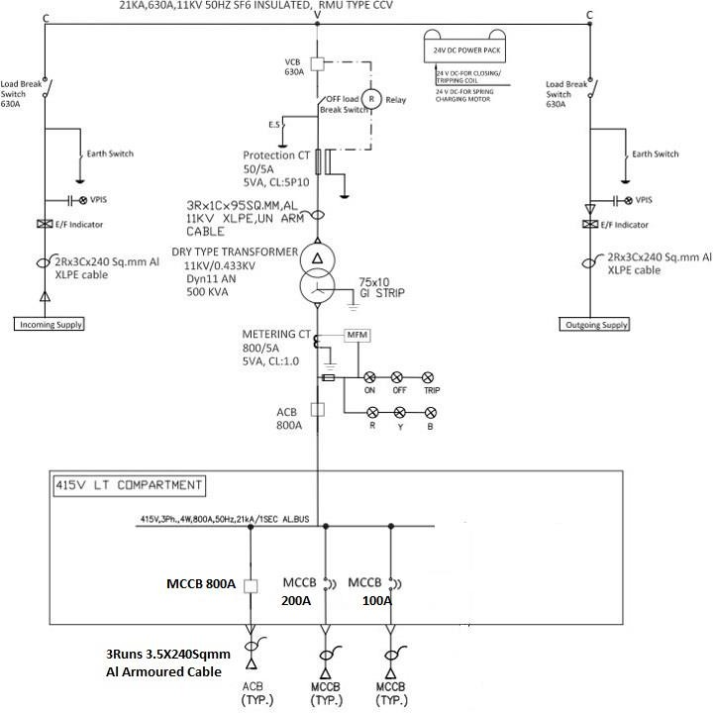
1(b) TECHNICAL SPECIFICATIONS FOR ITEM NO. 1(b)
This includes Installation, testing & Commissioning of Compact S/S, including Battery Charger, Safety Devices as per IS/BIS/DIN standard which includes outdoor type SF6 filled, with combinations of load break isolators & breakers. (including earthing- Erection of earthing by using GI strip (minimum 35mm strip) with earthing plate including cost of coal/salt to RMU).The Installation of 11KV Outdoor SF6 Insulated RMU covering erection, testing and commissioning with associated equipment including civil work, laying of 11kv cable, cable jointing kit etc. of RMU. The permission of Electrical inspector for charging of RMUs is in bidder scope. RMU fencing as shown below is in the scope of bidder the length and width of the fencing before erection the drawing should be approved by Engineer-in Charge. Cable termination kits, cable laying is in bidder scope
The Compact S/S shall be erected by using suitable size of M.S. channel (to be supplied & erected by contractor, as per each module approved foundation drawing) foundation bolts including grouting of the bolts of each unit in the panel. Each unit in the panel shall be connected with 2 separate and distinct earthing system the transformer neutral shall be properly earthed by Copper earthing rods the earthing should be chemical earthing . After installation of panel, necessary test and trial are to be carried out for proper functioning of safety, devices, relay etc. and before charging RMU Panel, all the tests required under relevant ISS and IEC – Rules 1956 shall be carried out and the result shall be in conformity with specifications and copies of test results shall be furnished to Engineer-in-Charge. The work includes supply & fixing of required length of insulated Rubber Mat having withstand capacity up to 22 kV, the Rubber Mat shall be laid in such a way, near the panel for operation of System.
The complete work shall be carried out as directed by Engineer-in-Charge. The side cable fix/adopter box wherever necessary/required shall be provided. If required, some alteration / modification is in the scope of contractor as per the instructions of Engineer-in-Charge. The work includes all labour & material required for installations, testing and commissioning of RMU as directed by Engineer-in-Charge.
The contractor shall provide the type & routine test certificates and also provides six sets of blue print layout drawings and manuals etc. The work includes all labour and material as directed by Engineer-in-Charge. The work shall be carried out as per Indian Electricity Rules.
2(a) TECHNICAL SPECIFICATIONS FOR ITEM NO. 02
Supply of Gas insulated 6-way extensible RMU switchgear & 4-way extensible RMU switchgear which should comply the requirement stated in the following standard & specification amended up to date.

Metal Enclosed Switchgear | IEC 62271-200/  IEC20 298/IS 12729:1988
Medium Voltage Switch | IEC 265
Alternation Current Dis-connector (Load Break Isolator & Earthing switch) | IEC 60129/ IEC 62271 - 102/  IS 9921
Specification of Alternation Current Breakers | IEC 62271- 100/IEC/60056/IS:13118:1991
Panel Design , SF-6 Circuit Breakers | IEC 62271-1/IEC 60694
Current Transformer | IEC 60044-1/IEC 60185/IS 2705:1992
HV switches | IEC 60265/IS 19920:1981
Filling of SF-6 in RMU | IEC 376
Pressure of SF6 gas | 1.4 bars at 20 °C
Cable bushings | DIN 47636
Temperature class | -25 °C - +40 °C Indoor
Degree of Protection:  - SF6 tank: IP 67  - Front cover: IP 2X  - Cable cover: | IEC 60273/IS 13947 (P-1) IP 67  IP 2X IP 3X
Bus bars | 240 mm2 Cu
Earth bar (external): | 120 mm2 Cu - Bolt dimension: M10
Colour Front Cover  Side & Cable Cover | RAL 7035  RAL 7035

General Requirement:
The Ring Main Unit shall be installed at existing 11/0.433 kV Substation, as per instruction of Engineer-in-charge. The RMU shall be both side extensible with two Circuit Breaker for incoming cable and Four Circuit breaker for outgoing feeder, shall be enclosed in the main tank using SF6 gas as insulating and vacuum as arc quenching medium or SF6 gas as both insulating and arc quenching medium. The main tank shall be stainless steel sheet of minimum 3mm thickness and robotically welded with a pressure relief arrangement. Incomer as well as Outgoing feeder shall be provided with Energy Meters.
The cable entry shall be from bottom and the end terminations shall be done on front side.

Inner enclosure (Main tank)
The tank shall be robotically welded stainless steel sheet of minimum 3mm thickness. The tank shall be sealed and no handling of gas should be required throughout the 25 years of service life. However, the SF6 gas pressure inside the tank shall be constantly monitored by a temperature compensating gas pressure indicator offering a simple go, no-go indication. The gas pressure indicator shall be provided with green pressure and red pressure zones. There shall be one Non - return valve to fill up the gas. The manufacturer shall give guarantee for maximum leakage rate of SF6 gas will be lower than 0.1% per Year. An absorption material such as activated alumina in the tank shall be provided to absorb the moisture from the SF6 gas to regenerate the SF6 gas following arc interruption. The degree of protection of the inner enclosure shall be IP 67.
The compact RMU Unit shall be provided with a suitable pedestal made up of M.S. Angle to mount the unit. The height of the bottom of cable box shall be minimum 310 mm to provide the turning radius for the HT cable termination.

BUS BARS:
Three nos. of continuous Bus bars made up of EC grade electrolytic copper of rating current 630A shall be provided. The Short time rating current shall be 20kA for 3 seconds for 11kV. The Bus bar connections shall Anti - oxide greased.
ELECTRICAL DATA:
    - 12 kV - 28kV - 1min
    - Nominal voltage: 11 kV
    - Rated frequency: 50 Hz
    - Rated current bus bars: 630 A
    - Rated current cable switch dis-connector: 630 A
    - Short time withstands current:
      - Cable switch dis-connector with interface C (400-bolt) bushing: 21 kA RMS 3 Seconds
      - Vacuum circuit breaker with interface C (400-bolt) bushing: 21 kA RMS 3Seconds
    - Rated current for transformer T-off: 630 A
    - Impulse withstands voltage: To earth and between phases: 95 kV
    - Insulation level: - Power frequency 1 min: 28 kV. Relay & Protection Scheme:
Numerical Relay with Control Supply 24V DC, 50Hz. Phase current input Relay shall be suitable for 1A and %A CT secondary (selectable at site). Relay shall be suitable for protection core CT connection. Metering core shall be connected to measuring instruments separately. Ground current input Relay shall be suitable for residually connected CT input. The relay shall haveprovision for digital inputs, speed switch inputs. The Communication System of the relay shall be equipped with RS485 for remote communication or for connection to DCS, SCADA or PLC. The relay shall be suitable for port for connection to Laptop & PC preferably of front side. Relay shall support Modbus Protocol. Relay shall be ABB REF615 / Siemens 7SR.

Front Plate:
The front shall include a clear mimic diagram which indicates different functions. The position indicators shall give a true reflection of the position of the main contacts and shall be clearly visible to the operator. The lever operating direction shall be clearly indicated in the mimic diagram. The manufacturer's plate shall include the switchboard's main electrical characteristics.

Danger Board:
The danger Board plate as per relevant IS shall be riveted on the front plate of the RMU in Languages viz. Gujarati, Hindi, English.

TYPE and ROUTINE TESTS:
Type tests:
The equipment offered in the tender should have been successfully type tested at NABL Laboratories in India or ERDA or equivalent international laboratories for the tests in line with the relevant standard and technical specification and manufacture to submit the valid type test certificates.

Following Type Test must have been carried out:
- Short time current withstand test and peak current withstand test.
- Lightening Impulse voltage withstand test.
- Temperature rise test.
- Short Circuit current making and breaking tests.
- Power frequency voltage withstand test (dry).
- Mechanical operation test.
- Checking of degree of protection of main tank and outer enclosure.
- Checking of partial discharge on complete unit.

ACCEPTANCE & ROUTINE TESTS:
All acceptance and routine tests as stipulated in the respective applicable standards amended up to date for all the equipment shall be carried out by the contractor in the presence of DPA representative & TPIA without any extra cost to DPA before dispatch.
The routine tests are as follows:
- Conformity with drawings and diagrams,
- Measurement of closing and opening speeds,
- Measurement of operating torque,
- Checking of filling pressure,
- Checking of gas-tightness,
- Dielectric testing and main circuit resistance measurement,
- Power frequency voltage,
- Resistance test for the circuit,
- Mechanical operation tests.
The contractor, in the presence of representative of DPA & TPIA, shall carry out all above acceptance and routine tests. The contractor shall give at least 15 days advance intimation to DPA to enable to depute representative for witnessing the tests.
The DPA reserves the right for carrying out any other tests of a reasonable nature at the works of the supplier/laboratory or at any other recognized laboratory/research institute in addition to the above mentioned type, acceptance and routine tests at the cost of the DPA to satisfy that the material complies with the intent of this specification.

DRAWINGS:
All drawings shall conform to relevant IEC Standards Specification. All drawings shall be in ink.
The Contractor shall submit dimensional general arrangement drawings of the equipment, illustrative and descriptive literature in triplicate for various items in the RMUs, which are all essentially required for future automation.
- Schematic diagram of the RMU panel
- Instruction manuals
- Catalogues of spares recommended with drawing to indicate each items of spares
- List of spares and special tools recommended by the supplier.
- Copies of Type Test Certificates as per latest IS/IEC.
- Drawings of equipment, relays, control wiring circuit, etc.
- Foundation drawings of RMU.
- Dimensional drawings of each material used for item (vi).
- Actual single line diagram of RMU with or without extra combinations shall be made displayed on the front portion of the RMU so as to carry out the operations easily.
The following should be supplied by contractor:
Copies in triplicate of printed volumes of operation, maintenance and erection manuals in English along with the copies of approved drawings and type test reports etc. sets of the manuals as above shall be supplied to the Engineer-in-Charge along with a soft copy of the all Technical and Drawing.

NAME PLATE:
Each RMU and its associated equipment’s shall be provided with a nameplate legible and indelibly marked with at least the following information.
- Name of manufacturer
- Type
- Serial number
- Voltage Current
- Frequency
- Symmetrical breaking capacity
- Making capacity
- Short time current and its duration
- Purchase Order number and date
- Month and Year of supply

TRAINING:
The contractor shall provide training to Operational Staff and Engineers of DPA. In case of training at manufacturer’s works is required, necessary expenses towards boarding, lodging & traveling for the deputed Engineers of DPA shall be borne by DPA.

PERFORMANCE GUARANTEE:
All equipment supplied against this specification shall be guaranteed for a period 12 months from the date of commissioning. However, any engineering error, omission, wrong provision, etc. which do not have any effect on the time period, shall be attended to as and when observed/pointed out without any financial implication on DPA.
The contractor shall supply at site 11 kV, 630 Amp, Indoor Compact Switchgear (Gas Insulated), Extensible on One Side, Motor Driven Spring Charging having 4 nos. Circuit Breaker Modules mentioned as under:
Module No. 1 as 11 kV Incomer along with PT, Module 2 & 3 as Circuit Breaker Module suitable for Distribution Transformer and Module No. 4 as spare 11 kV outgoing feeder suitable for Distribution Transformer.
The Circuit breaker modules shall be supplied with three position isolator/earthing switch, bus bars, interlocking, earth bar and stored spring energy mechanism.

Qty. for each module | Details of Module No. 1&2
1 | Stored energy mech. For manual and Motor Driven Spring Charged operation
1 | PT for incomer for metering purpose 11 kV/110 V, Class 0.5
1 | Multifunction Energy Meter with RS485
1 | Circuit breaker 12 kV, 630 A
1 | Control voltage, trip coil 24 V DC
1 | Protection system:  Relay must be Numeric type with following features:  - Self-Powered OC+EF Protection Relay  - Control voltage, 24 V DC  - Interference RS-485, RS232 port  - Equivalent to CAG 37 for Instantaneous Over Current  - Equivalent to CTUM 15 for short Circuit protection, Inst. Earth fault  - Instantaneous definite time & inverse type protection of over current.
1 | Set of three ring core metering & protection CTs:  CTs of 300-200/1-1A, 5P10, 2.5VA for protection and 300-200/1-1A CL 0.5,  2.5VA for metering  (considering the cable size 3Cx 300 sq. mm HT XLPE cable)

1 | Breaker ON(red)/OFF(green)/TRIP(amber) LED Indication
1 | Capacitive voltage indication fixed type
1 | Suitable Power Pack for Auxiliary DC Power supply for Relays

Qty. for each module | Details of Module No. 2, 3, 4 & 6
1 | Stored energy mech. for manual and Motor Driven Spring Charged operation
1 | Multifunction Energy Meter with RS485
1 | Circuit breaker 12 kV, 630 A
1 | Control voltage, trip coil 24 V DC
1 | Self-Powered OC+EF Protection Relay
1 | Set of three ring core metering & protection CTs:  CTs of 150-100/1-1A, 5P10, 2.5VA for protection and 150-100/1-1A CL 0.5,  2.5VA for metering (considering the cable size 3Cx 150 sq. mm HT XLPE cable)  Set of three ring core metering & protection CTs:  CTs of 300-100/1-1A, 5P10, 2.5VA for protection and 300-100/1-1A CL 0.5,  2.5VA for metering (considering the cable size 3Cx 300 sq. mm HT XLPE cable)
1 | Set of Transformer Protection Annunciation Scheme comprising of: 1 no. Master Trip Relay (24VDC)  6 no. Aux. Relays (24VDC)  1 no. 8-Window Annunciator & Hotter  Suitable for providing facility for Buchholz/OTI/WTI Alarm/Trip Indication,
1 | Breaker ON(red)/OFF(green)/TRIP(amber) LED Indication
1 | Capacitive voltage indication fixed type
1 | Suitable Power Pack for Auxiliary DC Power supply for Electro-Mechanical Aux Relays and Master Trip Relays

In addition to above following material to be supplied by Contractor for each panel.

Qty. | Material to be supplied by Contractor with each panel
6 | Set of Terminal Protector boots for covering cable-termination.
1 | Manometer installed on RMU for Gas Pressure indication.
2 | Operating handle
Note: The contractor shall provide 5 Years warranty against the low pressure of pre-filled SF6.gas in the RMU from the date of commissioning of RMU.
- Technical Specification No. 2(b):
The work also includes installations, testing and commissioning of supplied RMU panel at exiting 7th berth 11/0.433 kV Substation, Kandla.
All the RMU Panel application shall be erected by using suitable size of M.S. channel (to be supplied & erected by contractor, as per each module approved foundation drawing) foundation bolts including grouting of the bolts of each Module RMU panel. The RMU panel shall be connected with two separate and distinct earthing system. After installation of RMU panel, necessary test and trial shall be carried out for proper functioning of safety, devices, relay etc. and before charging RMU Panel, all the tests required under relevant ISS and IEC – Rules 1956 shall be carried out and the result shall be in conformity with specifications and copies of test results shall be furnished to Engineer-in-Charge. The work includes supply & fixing of required length of insulated Rubber Mat having withstand capacity up to 22 kV, the Rubber Mat shall be laid in such a way, near the panel for operation of RMU.
The complete work shall be carried out as directed by Engineer in Charge. The work includes required labour & material for installations, testing and commissioning of RMU as directed by Engineer in Charge.
- TECHNICAL SPECIFICATIONS FOR ITEM NO. 03
This includes supply, of 3Ph, 4 wire Tri Vector Energy Meter for HT O/g with DLMS protocol of accuracy class 0.2s, with Metering Panel. The meter should be capable to record & LED Display KWH, KVARh, KVAH & maximum demand in KVA for 3 phase 4 wire as well as 3 phase, 3 wire AC balanced / unbalanced loads for a power factor range ZERO (Lagging) through unity up to ZERO (Leading) as per requirement given in specification.
Application: - In 7th oil jetty Substation at 1 no. for Outgoing Panel for 1 mega watt GH2 plant
Sr. No | Items | Requirement
01 | Type | AMR compatible static, Tri Vector for 3phase, 4/3 phase 3 wires for tariff metering purpose.
02 | CT | 100-150/50-5 class 0.2s
03 | PT | 11KV/110 v Class 0.2s
04 | Ammeter | Digital type with selector switch
05 | Voltmeter | Digital type with selector switch
06 | Frequency | 50Hz(+-)5%
07 | Accuracy Class | 0.2s as per IS 14697/CBIP-88
08 | Secondary Voltage | For CT/PT operated HT Meters –suitable for operation from 110V Ph-Ph or 63.5V ph-N.
09 | Current | CT operated  I b ….1A,5A.  I Max…..200% of Ib.  Whole Current  Ib…..20Amps.  Imax……up to 600% of Ib.
10 | Power factor | 0.0lag-unity -0.0 lead
11 | Power Consumption | The active and apparent power in each circuit .
12 | Measured value | 4 quadrant measurement of KWH, KVARh, KVAh
13 | Parameter Shown in LED Display | 1, 3ph-ph to neutral Vg.  2, 3ph-ph to ph Vg.  3, 3ph-current.  4, 3ph KVA, KW, KVAR & PF Frequency.  5, Total voltage, Current, Frequency, KVAh, KWH, KVArh, PF& Average PF till last MD reset.  6, TOD KWH, KWH, KVARh (Lag & Lead) for 4 Zones.  7, rising demand.  8, prediction Demand KVA.  9, Max Demand with Date & Time.  10. TOD max Demand & date in 4 zones.  11. Cumulative MD & MD reset counts.
14 | Tamper Recording | Should be lag the following Tampers with date & Time of occurrence & restoration.  - Missing Potential.  - Missing I.  - I&V unbalance.  - Current Reversal.  Snapshot of V, I, PF, Energy at time of Tamper.  Flag for phase sequence, I reversal, V.
15 | Display | LCD with Backlight, 8 Digits, 7 Segment Display.  - Auto Scroll Display.  - 3 Display Modes.  - Up-Dn keys scroll.
16 | Maximum Demand | Up to 3 MD register can be programmed integration period programmable from 1 to 60 minute.  Reset: auto/manual/through.
17 | communication | Optical port as per IEC 1107.  -RS 232 port (optimal)  - RS 485 using MODBUS protocol (optimal).
18 | Data security | Data storage in non volatile memory 2 levels of password :-  For Data reading.  For programming.
19 | Design | Meter shall be designed with application specific integrated circuit (ASIC) or micro controller ; shall have no moving part; electronics component shall be assembled on printed circuit board using surface mounting technology; factor calibration using high accuracy (0.2s class) software based test bench.

Specification for Metering Panel.
Sr. No | Description | Specification
01 | MOC | CRC with bolted Structurer
02 | Thickness | 2.5mm for door  2.0mm rest of the structurer.  1.0mm for explosion vent.
03 | Main Bus Bar | 1X50X10 AL bus Bar.
04 | Earth Bus bar | 25X6 Al. Bus Bar
05 | Sleeves | Color Coded PVC sleeves
06 | Paint | RL 7032 Powder Coated after seven tank Process –Epoxy
07 | Power cable Entry | Bottom
08 | Control Cable entry | Bottom
09 | Wiring  For CT , PT Circuit  For Control Circuit | 2.5 Sq.mm Stranded cu wire  1.5 Sq.mm Stranded cu wire
10 | Installation | Indoor Type Floor Mounted free standing.
11 | Over All Dimension | 600X900X1800mm
12 | Min Clear Draw Out Space | 1.2Mtr.
13 | Weight | 200 Kg approx.
14 | Testing offered | Polarity & CT /PT primary injection.

4. TECHNICAL SPECIFICATIONS FOR ITEM NO. 04

This includes installation Metering Panel at the S/s wiring includes necessary wiring connection & earth linking, the works also include CT, PT shall be Tested in ERDA Lab and Meter should Test in PGVCL authority Lab, in this regard contractor shall be submitted the Test Report of CT, PT , HT Tariff Meter Works comprise with all material, licensing ,labour tolls & tackles as directed by EIC.
5. TECHNICAL SPECIFICATIONS FOR ITEM NO. 05.
- This include supply at site outdoor & indoor type heat shrink end termination kit for 3 core, 300 Sq. mm HT armored aluminum conductor XLPE Cable of 11 kV grade as per the approved make list.
- This include supply at site Straight through heat shrink kit for 3 core, 300 Sq. mm HT armored aluminum conductor XLPE Cable of 11 kV grade as per the approved make list.

- TECHNICAL SPECIFICATIONS FOR ITEM NO. 06.
This item includes supply at site 3 Core, 150 Sq. mm & 3 core 300 Sqmm (U/E) XLPE Insulated 11kV grade aluminum conductor XLPE insulated armoured cable confirming to IS: 7098 (Part-II) 1988 with latest amendments with ISI mark. The cable shall have marking/embossing at the interval of every meter showing its progressive length. The contractor shall submit type test certificate at the time of supply of Cable at site. The type test certificate shall not be more than 3 years old. The rate shall be inclusive of all taxes (excluding GST), packing, forwarding, insurance, transportation, and unloading at site of work.

- TECHNICAL SPECIFICATIONS FOR ITEM NO. 07.
- The item includes laying of single length / double length cable up to the size of 3 Core x 300 Sq. mm (U/E) XLPE Insulated aluminium conductor XLPE insulated armoured cable of 11kV grade in the existing substation cable trench. The cable shall be laid after opening of trench by removing the MS chequered plates. If any unwanted cable or waste is available in the trench the contractor should clean the trench before laying the new cable and obtaining clearance in writing from Engineer-in- charge. After laying of the cable, cable trench shall be properly covered with existing chequered plates as per original. The item includes required material and labour as directed by Engineer in charge.
- The item includes laying of single length / double length cable up to the size of 3 Core x 300 Sq. mm (U/E) XLPE Insulated aluminium conductor XLPE insulated armoured cable of 11kV grade through excavation in hard/soft soil. The trench to be excavated of 300 mm width & 1.5 meter depth. The bed of 50mm of river sand shall be provided in the bottom of the excavated trench. The cable shall be laid over the bed of river sand. The cable shall be protected as per Sketch shown below by providing and laying bricks both the sides lengthwise parallel to the cable & the gaps shall be filled with river sand. The cable shall be covered by keeping two bricks over the side bricks shown in the sketch. The filling of the trench shall be done with the excavated stuff & should be watered and rammed properly to its original position. The excess excavated stuff shall be disposed off from the Site of work and separated in low laying area as directed. The item includes required material and labour as directed by Engineer in charge.
Sketch
Top Brick

Side Brick

Cable
- The item includes laying of single length / double length cable upto the size of 3 Core x 300 Sq. mm (U/E) XLPE Insulated aluminum conductor XLPE insulated armoured cable of 11kV grade in the existing NP2 Pipe Trench. The cable shall be passed through the existing NP2 pipe after opening & removing RCC trench manhole cover. After laying of the cable, the manhole shall be properly covered with existing removed RCC covers as per its original position. At every approximately 30m length of NP2 Pipe, a suitable size of manhole exists. The item includes required material and labour as directed by Engineer in charge.

- Asphalted /RCC Road:-
Cable shall be laid through Asphalted Road /RCC Road by providing & laying 150 mm diameter G.I pipe, the trench to be excavated 0.3 Mtr wide 1.0 Mtr deep by JCB/ Pneumatic breaker / excavator . if Road/RCC crossing length more than length of standard length of G.I pipe, then firm shall joint/welded by putting double flange for both end & to be coupled both end with nut &bolts between two pipe & then lay across Road, the single cable shall be passed through one pipe, the excavated stuff shall be disposed off from the Site of work and spreaded in low laying area. After that re-filling with sand cushioning & 300mm CC/RMC work done on by proper curing or its original position. This includes all labour and material as directed by Engineer-in-Charge.
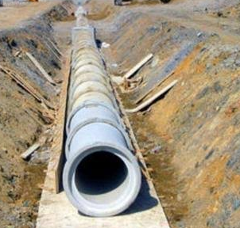
- In Rail Crossing/RCC Road Crossing through HDD::-
Cable shall be laid underneath by using {16” Boar Diameter} Horizontal Directional Drilling (HDD) method by putting suitable diameter HDPE (suitable for cable size up to HT 3CX 400 Sq.mm} HDPE pipe having strength 10Kg/sq.cm} shall in contractor scope), the contractor shall arranged JCB Machine for excavation, water for drilling, de- watering pump, HDD equipments at their own cost. The cable shall be pass through heavy duty HDPE pipe buried at nominal minimum depth 165 cm or according to construction of RCC Road/ Rail network or as per directed by EIC. For single cable individual HDPE shall be pass through a road /rail crossing, for separate cable; separate HDPE pipe shall pass through the Tunnel / trench. Lying of HDPE pipes coupled by HDPE socket only after standard length in excavated trench/tunnel and also sealing of HDPE pipe ends by suitable cap at every manhole. Back filling & dressing of excavated trenches as per specification. This includes all labour and material as directed by Engineer-in-Charge.
CABLE ROUTE AND JOINT MARKERS
  - Permanent means of indicating the positions of joints on site should be provided. During the course of permanent reinstatement cable and joint markers, should be laid directly above the route of the cable and the position of the joint respectively.
  - Wherever it is not possible to place the marker directly over the cable route or joint the marker should be suitably placed near the cable route or joint on which the distance of the cable route or joint at right angles to and parallel to the marker should be clearly indicated.
  - The site requirement & position of fixing the markers will be decided by the Engineer-In-charge or his nominee.
  - The type of route marker & letters to be written on the route marker will be decided while execution by the Engineer-in-charge.
  - Route marker should be visible and the pedestal should be buried underneath the ground firmly by providing CC foundation.
  - Route Marker of C.C. (1:2:4) 150x150x750 (in mm) Concrete Stone (DPT Mark with Approved Yellow Color Embedded in Earth atleast 300 mm below the ground Level at Approx. Distance 10 Meter or as directed by EIC
Cable laying, shall include the route marker, cable tagging, dressing, removing the old unused cable from the RCC Trench, appropriate size of glands & ferrule work as per requirement etc.

- TECHNICAL SPECIFICATIONS FOR ITEM NO. 08.
This includes supply at site 1.1 kV grade, following size of aluminum conductor XLPE insulated armoured cable confirming to IS: 7098 (Part-I) 1985 with up to date amendments and of approved make either of any following make POLYCAB/TORRENT/RPG ASIAN/ NICCO/ HAVELLS / UNISTAR with ISI mark. The cable shall have marking/embossing at the interval of every meter showing its progressive length. The make of the LT cable should be
The size of LT armoured XLPE aluminum conductor cable are:
- 4 Core, 300 Sq.mm,
- 4 Core, 150 Sq.mm,
- 4 Core, 95 Sq.mm,
- 4 Core, 70Sq.mm,
- 4 Core, 35 Sq.mm,
The contractor shall submit type test certificate at the time of supply of Cable at site. The type test certificate shall not be more than 3 years old. The rate shall be inclusive of all taxes (excluding GST), packing, forwarding, insurance, transportation, and unloading at site of work.
- TECHNICAL SPECIFICATIONS FOR ITEM NO. 09.
This includes laying & end termination of 1.1 KV grade XLPE armoured L.T cable of following size in proposed Steel Structure / wall /Beam / G.I pipe of suitable size or in a trench to be excavated by digging asphalted road, paved area covered with RCC Slabs, soiled area with stone etc including excavation of hard and soft soil as per the case may be and provided sand cushioning at the bottom and above the cable and by providing second class bricks including refilling of trench as mentioned below. The contractor shall not allow lay the cables without Jacks. While laying the cables, drums of cables shall be placed on the Jacks strictly for pulling the cables for laying to avoid any damage to cables.
- Laying of Cable:
The item includes laying of laying of LT armoured aluminum Conductor XLPE Cable of 11KV Grade (excluding supply of cable) single length / double length cable upto the size of 4 Core x 300 Sq. mm XLPE Insulated aluminum armoured cable of 1.1kV grade in the existing substation cable trench. The cable shall be laid after opening of trench by removing the MS chequered plates. If any unwanted cable or waste is available in the trench the contractor should clen the trench before laying the new cable and obtaining clearance in writing from Engineer-in- charge. After laying of the cable, cable trench shall be properly covered with existing chequered plates as per original. The item includes required material and labour as directed by Engineer in charge.
- In Hard/Soft Soil: This includes laying of single length HT/LT armoured aluminum Conductor XLPE Cable of 11KV Grade (excluding supply of cable) through excavation in soft/hard soil. The trench to be excavated 0.3 mtr. wide 1.0 mtr. deep. The bed of 50mm of river sand shall be provided in the bottom of the excavated trench. The cable shall be laid over the bed of river sand. This includes providing & laying of bricks on both sides of cable lengthwise i.e. parallel to the cable and the gaps shall be filled by fresh river sand. The cable shall be covered by keeping two bricks over the side bricks shown in the sketch. The filling of the trench shall be done with the excavated stuff & should be watered and rammed properly to its original position. The excess excavated stuff shall be disposed off from the Site of work and separated in low laying area as directed. The same trench would be used to place two circuits (cables) side by side in horizontal fashion.
The contractor shall provide heat shrinkable straight through joints of relevant size of approved make if the laying of cable shall be more than standard drum length. This includes all labour and material as directed by Engineer-in-Charge. Such cable joints shall be under the scope of work of the contractor at no extra cost or obligation from DPA. Such cable joining work is completely to be done by the contractor at his own cost. The rates shall be inclusive of all material, required tools tackles and labour and as directed by Engineer-In-charge, but excluding GST.
Sketch
Top Brick

Side Brick

Cable
Fig 1.1
- Laying on walls, cable tray beam: The work consists of laying LT cables on wall surface, beam, cable tray, etc. with suitable size of G.I. saddles/spacer of 2mm thick and shall be rigidly fixed on cemented wooden gutties or polymeric gutties at a distance of not more than 0.5 mtr interval. And wherever the cable is to be run on tray same shall be fixed with suitable size of clamp & hardware. This also includes termination at both ends by required size of cable gland and with suitable size of lugs with all material and labour and as directed by Engineer-in-charge.
- In ½ Round RCC Hume pipe The item includes laying of single length cable of size 4 core x 50 Sq.mm & 4C x 70Sqmm LT armoured aluminum Conductor XLPE Cable of 1.1KV Grade both in the ½ round RCC hume Pipe 6” I/D the half round pipe should be laid on the coarse sand. The cable shall be laid on the existing half round pipe as shown in the drawing after laying of cable the pipe should be filled with fine sand and covered with half round pipe.. At every approximately 15mtr length of there should be inspection chamber provided. The item includes required material and labour as directed by Engineer in charge.
Fig 1.2
- Through HDPE Pipe under rail/road crossing/muddy area: This includes making of Horizontal Directional Drilling of suitable dia including putting suitable diameter HDPE. HDPE pipe shall have strength of 10Kg/Sq.cm. Providing of HDPE pipe is also in the scope of contractor. Depth of horizontal boring shall be minimum 165 cm or according to construction of Road/Rail network/muddy area or as per direction of Engineer-In- Charge. Laying of HDPE pipe coupled by HDPE socket only after standard length in excavated trench / tunnel and also sealing of HDPE pipe ends by suitable cap at both end. After completion of boring job back filling & dressing of excavated trench to be carried out as per the original. The contractor shall arrange JCB machine for excavation, water for drilling, de-watering pump, HDD equipment at their own cost. The rates shall be inclusive of all material, required tools tackles and labour and as directed by Engineer-In-charge, but excluding GST. The two circuits (cables) to be laid in the separate HDPE pipe. side by side in horizontal fashion.

This includes also includes passing of HT/LT cable through buried HDPE pipe. The pipe shall be sealed at both the end by suitable cap after the laying of cable in HDPE pipe. The rates shall be inclusive of all material, required tools tackles and labour, as directed by Engineer-In-charge, but excluding GST.
This also includes end termination of cables at both the sides including cable glands etc. Termination and jointing kits for 1.1 KV grade XLPE cables shall be proven approved make. A loop of sufficient length shall be kept for future requirement. The contractor should provide cable route marker fixed on the M.S angle and properly grouted on the ground showing the size of the cable running.
L.T cable termination & jointing shall be done strictly in accordance with kit manufacturer’s instructions, drawing and as directed by Engineer-in-Charge. Cable jointer shall be qualified to carry out LT/ HT cable jointing and termination work. The work includes all material and labour as directed by Engineer-in-charge.
CABLE ROUTE AND JOINT MARKERS
  - Permanent means of indicating the positions of joints on site should be provided. During the course of permanent reinstatement cable and joint markers, should be laid directly above the route of the cable and the position of the joint respectively.
  - Wherever it is not possible to place the marker directly over the cable route or joint the marker should be suitably placed near the cable route or joint on which the distance of the cable route or joint at right angles to and parallel to the marker should be clearly indicated.
  - The site requirement & position of fixing the markers will be decided by the Engineer-In-charge or his nominee.
  - The type of route marker & letters to be written on the route marker will be decided while execution by the Engineer-in-charge.
  - Route marker should be visible and the pedestal should be buried underneath the ground firmly by providing CC foundation.
  - Route Marker of C.C. (1:2:4) 150x150x750 (in mm) Concrete Stone (DPT Mark with Approved Yellow Color Embedded in Earth atleast 300 mm below the ground Level at Approx. Distance 10 Meter or as directed by EIC
Cable laying, shall include the route marker, cable tagging, dressing, removing the old unused cable from the RCC Trench, appropriate size of glands & ferrule work as per requirement etc.

- TECHNICAL SPECIFICATIONS FOR ITEM NO. 10.
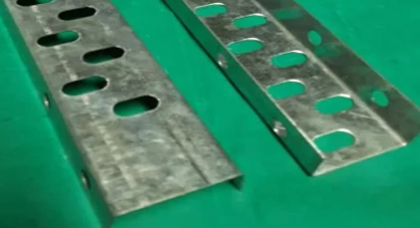
This includes supply of Cable Trays & Accessories, Tray Covers and Fittings:
SL | DESCRIPTION | . SPECIFICATION
1 | ITEM | Cable Tray
2 | APPLICABLE STANDARD | IS-1079 Grade0, IS 2629, IS 2633
3 | TRAY SIZE | 50mm (W) x 25 mm (H)
4 | TRAY TYPE | PERFORATED
5 | MATERIAL OF CONSTRUCTION | MS H.R. SHEET AS PER IS 1079 Grade 0
6 | TRAY LENGTH (EACH PIECE) | 2.5 METER.
7 | TRAY / COUPLER PLATE THICKNESS | 2 mm (+/- 0.2 mm)
8 | ACCESSORIES | EACH TRAY LENGTH SHALL BE SUPPLIED WITHSUITABLE COUPLER PLATES, NUTS, BOLTS AND WASHERS.
9 | GALVANIZING STANDARD. | AS PER IS 2629 & IS 4759
10 | PURITY OF ZINC | 99.5% AS Per IS 209, 1992.
11 | THICKNESS & MASS OF ZINC COATING | 75-micron average & 610 gms/m2
12 | FINISH | A. Perforated tray – Hot dip galvanized B. Nut, Bolt

- TECHNICAL SPECIFICATIONS FOR ITEM NO. 11.
This include fabrication & Installation of perforated type cable trays including horizontal, vertical bends, reducers, tees, cross members & other accessories as required and duly suspended from the ceiling and /or fix to steel/RCC columns, beams or any other structure members with MS suspenders, angles, channels with all required material, accessories and labors as directed by Engineer-In-charge.

- TECHNICAL SPECIFICATIONS FOR ITEM NO. 12.
This includes design, manufacture and supply at site Out door type Main Vertical 18 Way LT Distribution Panel suitable for 415 Volts, 3ph, 4 wire, 50 Hz. AC supply system including all switchgears and internal wiring. The panel shall be dust and vermin proof, single front type, indoor type, and fabricated from CRCA sheet steel of 2.0 mm. thickness. The panel shall be mounted on 75 mm. x 40 mm. “C” Channel. The panel shall be painted with SIEMENS grey paint. Before painting the panel, the surface treatment shall be carried out by 7-tank process. The panel shall be provided with metallic engraved/Radium film labels on front for identification of Incoming & Outgoing feeders as directed. The neoprene gaskets shall be provided on the periphery of the doors of all feeders. The sleeved electrolytic copper busbars with epoxy insulators with Bakelite support and separators shall be provided with colour code. The panel shall be complete in all respect with cable glands, lugs for incoming & outgoing cables and also shall be provided with 2 nos. of earthing terminals.
The panel shall be comprised with following accessories:
1. INCOMER FEEDERS
Incomer Feeders 2 nos.
The Main Incomer Feeder shall be provided with 1 nos. 800 Amps. X 415 Volts Triple Pole – MDO (Draw out type) ACBs (Air Circuit Breaker) with over current, Short circuit and Earth fault relay for each feeder. The Digital Multi-Function Meter 1 No. for each feeder with analog Voltmeter and Amp. meter of size 120 x 120mm.
The LED Indication lamps 6 nos. for R, Y, B, ON, OFF and trip indication shall be provided on each feeder. CTs 3 nos. having ratio of 800/5 Amps shall be provided for metering on each feeder. Control fuses / neutral links 4 nos. are to be provided with each incomer. The control wiring shall be done with copper wire. The Incomers shall be mechanically and electrically interlocked.
Bus coupler Feeder: 1 No.
The Bus Coupler shall be provided with 1 nos. 800 Amps. X 415 Volts Triple Pole – MDO (Draw out type) ACBs (Air Circuit Breaker) with Static Release Over current, Short circuit and instantaneous relay. The LED Indication lamps 3 nos. for ON, OFF and trip indication shall be provided on Bus Coupler feeder.
Control fuses and neutral links are to be provided with Bus Coupler & the control wiring shall be done with copper wire. The Bus Coupler shall be mechanically and electrically interlocked.
2. OUTGOING FEEDERS
A) OUTGOING FEEDERS TYPE-1 (10 Nos.):
This type of Outgoing Feeders shall be provided with 1 nos. 400 Amps. X 415 Volts 50KA Breaking capacity MCCB, for each feeder. The LED Indication lamp 1 no. for ON indication shall be provided on each feeder. The control wiring & power wiring shall be done properly and the power wiring shall be brought up to the Power terminal block of suitable ampere capacity
B) OUTGOING FEEDERS TYPE-2 (4 Nos.):
This type of Outgoing Feeders shall be provided with 1 nos. 300 Amps. X 415 Volts, 50KA Breaking capacity MCCB, for each feeder. The LED Indication lamp 1 no. for ON indication shall be provided on each feeder. The control wiring & power wiring shall be done properly and the power wiring shall be brought up to the Power terminal block of suitable ampere capacity.
C) OUTGOING FEEDERS TYPE-3 (1Nos.): This type of Outgoing Feeders shall be for street light having 1 no digital timer, 1 no 3Pole / 4 pole 100A contactor having both NO & NC contact 1 no 63A 4 pole with internal wiring
The LED Indication lamp 1 no. for ON indication shall be provided on each feeder. The control wiring & power wiring shall be done properly and the power wiring shall be brought up to the Power terminal block of suitable ampere capacity.
The panel shall be designed, fabricated and supplied from manufacturers who are having type test certificate holders, i.e. CPRI/ERDA of similar capacity not less than 3 years.
The design of the panel should be such that it should accommodate in the existing Substation accordingly before fabrication / design of panel. The contractor should visit the site and submit the drawing and BOQ of panel with their make & line diagram along with dimension of the panel for approval of Engineer-in-Charge. The Contractor shall manufacture the panel only after getting written approval from Engineer-in-charge. The material shall be used from KPT approved make.
- TECHNICAL SPECIFICATIONS FOR ITEM NO. 13.

This includes Erection / Installation, testing and commissioning of supplied L.T distribution panel, dust and vermin proof, free standing, compartmentalized, fabricated from 2mm thick SWG CRCA sheet steel.
The panel shall be firmly installed in existing approach of the SNA jetty at the existing location over trench line with proper size of foundation bolts on “C” channel of 75 x50 x 6 mm size after proper alignment of the panel. If required necessary CC foundation of suitable height should be constructed over which the fabricated channel shall be properly grouted on the floor using proper size of grouting bolts, along with this the contractor has to provide shed using box channel of suitable size over the panel to safe guard from heavy rains the size & height of the shed should be approved by Engineer-in-charge.
This work includes end terminations of Incoming and outgoing cables in all respect with cable glands, lugs for incoming & outgoing cables and also connections of earthing with 2 nos. of earthing terminals with supplied panel. The panel shall be commissioned as per relevant IS specification and IE rules-1956 with update amendments. The results of the test shall be confirming to the relevant IS specification and copies of the results shall be furnished to Engineer-in-charge by Contractor. The work includes all labour and material including necessary civil work as directed by Engineer-in-Charge.
- TECHNICAL SPECIFICATIONS FOR ITEM NO. 14.

This includes design, supply at site, installation, testing and commissioning of outdoor pedestal type Main Distribution Panel with top canopy, double shutter, handle with locking arrangement (pad lock – 5 levers with keys), dust, damp and vermin proof. The panel shall be dust and vermin proof, single front type, indoor type, and fabricated from CRCA sheet steel of 2.0 mm. thickness. The panel shall be mounted on 75 mm. x 40 mm. “C” Channel. The panel shall be painted with SIEMENS grey paint. Before painting the panel, the surface treatment shall be carried out by 7-tank process. The panel shall be provided with metallic engraved/Radium film labels on front for identification of Incoming & Outgoing feeders as directed. The neoprene gaskets shall be provided on the periphery of the doors of all feeders. The sleeved electrolytic copper busbars with epoxy insulators with Bakelite support and separators shall be provided with colour code. The panel shall be complete in all respect with cable glands, lugs for incoming & outgoing cables and also shall be provided with 2 nos. of earthing terminals.
The L.T Distribution panel shall be specious for easy maintenance and shall be specious to be provided with all the material mentioned below.
- 400A, 415 Volt 50 Hz Open Execution 4 pole change over Switch : 1No.
- 300A 415 Volt 50Hz 35KA breaking capacity MCCB : 4No.
- 260A, 415 Volt 50Hz 50Hz 35KA breaking capacity MCCB : 2No..
- Suitable size ammeter & Voltmeter for the above panel : 1 each
- 4 Way Selector switch unit complete for Voltmeter/Ammeter. : 2 Nos.
- LED Indication lamps Red, green and amber blue 230/240v AC for each feeder
- Digital Multifunction Meter suitable for above panel : 1No.
- Electrolytic grade copper bus bar for Phase & Neutral, PVC sleeved with colour code, Danger Board, tie belt, M.S Wall mounted stand etc.
All these components shall be mounted in the panel by means of suitable cadmium passivated hardware. The panel shall be complete in all respects with cable glands, lugs for incoming and outgoing cables including interconnection with PVC insulated cable single core, standard copper conductor of 650/1100V grade.
The panel shall be tested as per IS. The panel shall be provided with 2 Nos. S.S. terminals for earthing. The Panel shall be manufactured from type test holder having type test certificate of feeder panel of similar or above ratings.
The design of the panel should be such that it should accommodate the switch gears indicated above. The contractor should visit the site and submit the drawing and BOQ of panel with their make & line diagram along with dimension of the panel for approval of Engineer-in-Charge. The Contractor shall manufacture the panel only after getting written approval from Engineer-in-charge. The material shall be used from DPA approved make.
- TECHNICAL SPECIFICATIONS FOR ITEM NO. 15.
This includes design, supply at site, installation, testing and commissioning of outdoor pedestal type 160A, 50HZ , 440V Heavy duty industrial metal Plug &Socket for Power plug point panel with top canopy, double shutter, handle with locking arrangement (pad lock – 5 levers with keys), dust, damp and vermin proof. The panel shall be dust and vermin proof, single front type, indoor type, and fabricated from CRCA sheet steel of 2.0 mm. thickness. The panel shall be mounted on 75 mm. x 40 mm. “C” Channel. The panel shall be painted with SIEMENS grey paint. Before painting the panel, the surface treatment shall be carried out by 7-tank process. The panel shall be provided with metallic engraved/Radium film labels on front for identification of Incoming & Outgoing feeders as directed. The neoprene gaskets shall be provided on the periphery of the doors of all feeders. The sleeved electrolytic copper busbars with epoxy insulators with Bakelite support and separators shall be provided with colour code. The panel shall be complete in all respect with cable glands, lugs for incoming & outgoing cables and also shall be provided with 2 nos. of earthing terminals.
- 260A 415 Volt 50Hz 35 KA breaking capacity MCCB : 1No.
- 200A, 415 Volt 50 Hz Open Execution 4 pole change over Switch : 1No.
- Heavy duty industrial metal plug Surface mounted 160 Amp High voltage 4 pin Socket 380V 50Hz, Protection IP 67 (make Power & pack /Schneider) : 2No.
- Heavy duty industrial metal Socket Surface mounted 160 Amp High voltage 4 pin Socket 380V 50Hz, Protection IP 67(make Power & pack /Schneider) : 2No.
- 3 Phase 4 wire, -/5A, LTCT operated or direct reading with range 200/5 : 1 No
- Voltmeter & Ammeter along with selector switch : Comp Set.
- LED Indication lamps Red, green and amber blue 230/240v AC for each feeder
- Electrolytic grade copper bus bar for Phase & Neutral, PVC sleeved with colour code, Danger Board, tie belt, M.S Wall mounted stand etc.
All these components shall be mounted in the panel by means of suitable cadmium passivated hardware. The panel shall be complete in all respects with cable glands, lugs for incoming and outgoing cables including interconnection with PVC insulated cable single core, standard copper conductor of 650/1100V grade.
The panel shall be tested as per IS. The panel shall be provided with 2 Nos. S.S. terminals for earthing. The Panel shall be manufactured from type test holder having type test certificate of feeder panel of similar or above ratings.
The design of the panel should be such that it should accommodate the switch gears indicated above. The contractor should visit the site and submit the drawing and BOQ of panel with their make & line diagram along with dimension of the panel for approval of Engineer-in-Charge. The Contractor shall manufacture the panel only after getting written approval from Engineer-in-charge. The material shall be used from DPA approved make.
- TECHNICAL SPECIFICATIONS FOR ITEM NO. 16.
This includes Erection / Installation, testing and commissioning of Main Distribution Panel, Plug Point Power Panels. All the panels shall be erected on cement concrete platform duly plastered with tapped collar of suitable size having height of 500 mm above ground level including grouting of M.s channel legs of suitable size of the feeder pillar in reinforced foundation of suitable design.
This includes end terminations of Incoming and outgoing cables in all respect with cable glands, lugs for incoming & outgoing cables and also connections of earthing with 2 nos. of earthing terminals with supplied panel. The panel shall be commissioned as per relevant IS specification and IE rules-1956 with update amendments. The results of the test shall be confirming to the relevant IS specification and copies of the results shall be furnished to Engineer-in-charge by Contractor. The work includes all labour and material including necessary civil work as directed by Engineer-in-Charge.
- TECHNICAL SPECIFICATIONS FOR ITEM NO. 17.
The Contractor shall have to do the entire work of earth pits required for equipment earthing and for the pits at the corners of earth mat.
STANDARDS

The product and the equipment covered by this specification shall, unless otherwise specified be in line with the requirement of any of the latest applicable standards and will apply in order of priority as listed below:-
a) Indian Standards
b) IEEE 80
c) ANSI (American National Standards)
d) BS (British Standards)
EARTH PITS
All the Earth Pit shall be with special Ground electrodes supplied by Reputed Manufacturer. These special electrodes are provided with Ground enhancement material.
PIPE or PIP (Pipe-In-Pipe) or Flat-In-Pipe ELECTRODE for 11KV Substations: -
The Pipe or Pipe-In-Pipe or Flat-In-Pipe electrode shall have a nominal (actual) outer dia. of 50 mm & 2.5 mm thickness (Min.) and length of 3 M (Min.). It shall be capable of handling 25 KA 1-Sec Short time current and shall have a molecular bonding of 250 micron of copper as per international standards.
Diameter | 50 mm
Length of Rod | 3 meter
Size of Conductor | (25x3)mm

In case of P-I-P and Flat-In-Pipe, the portion between pipes shall be filled with the conductive material.
- Type test report (tested at NABL accredited laboratory) shall be submitted satisfying minimum STC of 25 KA-1Sec for 11 KV S/S
- Test report (tested at NABL accredited laboratory) of cu-coating shall be submitted satisfying our requirement of 250 micron coating.
GROUND ENHANCEMENT MATERIAL/ BACK FILL / GROUNDING COMPOUND
Ground Enhancement Material/ Backfill / Grounding compound shall be permanent and maintenance free. (No re- charging with salts or any other chemicals) and shall maintain its earth resistance with time.
Ground Enhancement Material/ Backfill / Grounding compound shall confirm IEEE 80-2000 Clause No.14.5 (d). Ground Enhancement Material/ Backfill / Grounding compound in its set form shall have a resistivity of not more than 0.12 ohm-m.
Ground Enhancement Material / Backfill / Grounding compound shall comply the requirements and all applicable tests as per part-7 of IEC 62561. The same shall be tested at NABL accredited laboratory and reports are to be verified at site.
Resistivity test using soil box
Leaching test
Sulphur determination
Corrosion test
It must set up firmly and not dissolve or decompose or otherwise pollute the soil or the local water table.
It shall be suitable for use in dry form or slurry form.
The Ground Enhancement Material/ Backfill / Grounding compound shall not depend on the continuous presence of water to maintain its conductivity.
The material shall be carbon based conductive concrete and shall not contain bentonite in any form.
Same shall be applicable for conductive material used for filling in case of P-I-P and Flat-In- Pipe type earth electrodes.
CLAMP
Each Earth Rod/Pipe/PIP must be provided with a suitable Cu plated clamp OR exothermic welding of Cu plated plate to facilitate Interconnection of rods and connection to Equipment Earth Bar using appropriate copper coated MS strip.

Earthing Pit

- Specially designed for earthing Inspection.

- Durable mild FRP cover and body.

- Square top to aid block pavior cutting.

- Giving a neat edge design. Circular

- Clear opening to fit inspection chambers.

- Solid tray base plate.

GUARANTEE.
The product shall be guaranteed for trouble free operation. Any defect discovered during this period shall be rectified free of charge. The pits shall be drawn with the help of a boring machine, an auger or any other means as required by site conditions and nature of ground strata which shall be in the scope of supplier.
A cement concrete (ratio 1:4:8) chamber of at least 30 cm x 30 cm shall be provided just below the surface of ground over the funnel for watering and having RCC/CI cover of suitable size as directed. The pit shall be filled with alternative layer of 15cm each of charcoal and salt. This also includes removal of extra-excavated earth from the site. The work shall be carried out to entire satisfaction of Engineer-in-charge. This work includes all labour and material as directed by Engineer-in-charge.

- TECHNICAL SPECIFICATIONS FOR ITEM NO. 18.
  - This item includes supply at site, laying, fixing and connection of Copper strip of size 50x6 mm from earth station to HT RMU Panel/ Distribution Transformer/ LT Distribution Panel/ Load point panel as directed. The GI strip shall be laid and clamped suitably on wall/floor/structure or buried in the ground as directed. This work includes all material, labour, tools & tackles as directed by Engineer-In-Charge.
  - This item includes supply at site, laying, fixing and connection of GI strip of size 40x6 mm from earth station to Feeder Pillar as directed. The GI strip shall be laid and clamped suitably on wall/floor/structure or buried in the ground as directed. This work includes all material, labour, tools & tackles as directed by Engineer-In-Charge.

- TECHNICAL SPECIFICATIONS FOR ITEM NO. 19.
This includes supply at site, laying, fixing and connecting of G.I wire of size 8 SWG from earth station/existing earthing system to Junction Boxes/Distribution Boards/lighting accessories etc. as directed. The G.I wire also shall be laid from earth station to Junction Boxes/Distribution Boards/lighting accessories etc. directly connected to two separate and distinct main earth as directed and shall be clamped suitably on wall/floor or buried in the ground / pucca trench as directed. The work includes all material & labour required shall be done as directed by Engineer-in-charge.

---SD--
Signature & Seal of Contractor Executive Engineer (E)
Deendayal Port Trust

Fig no 1

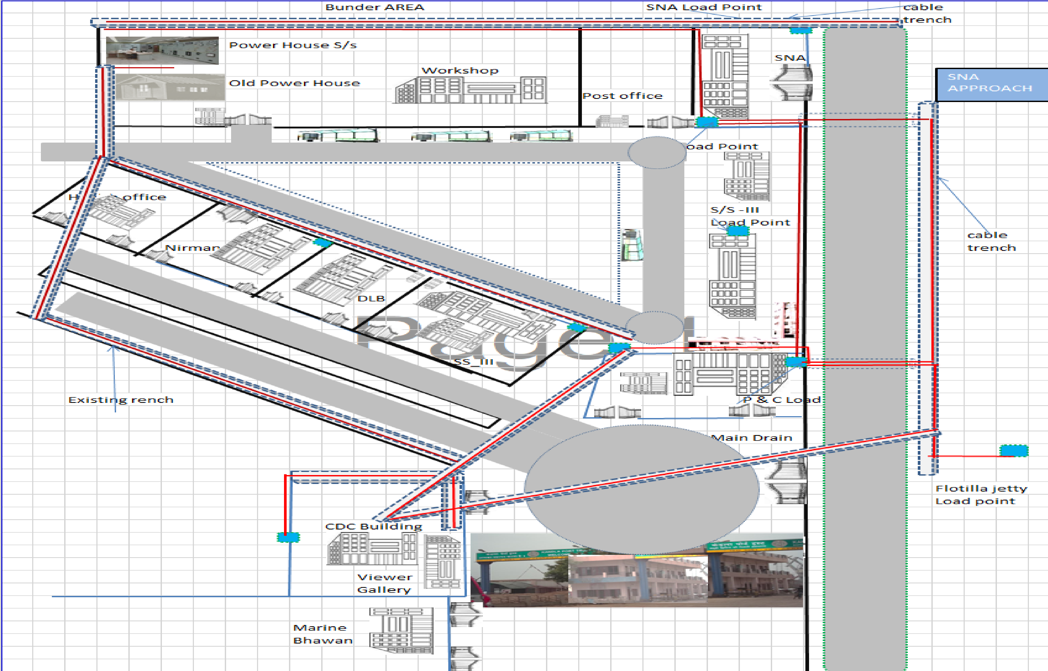

Fig no 2
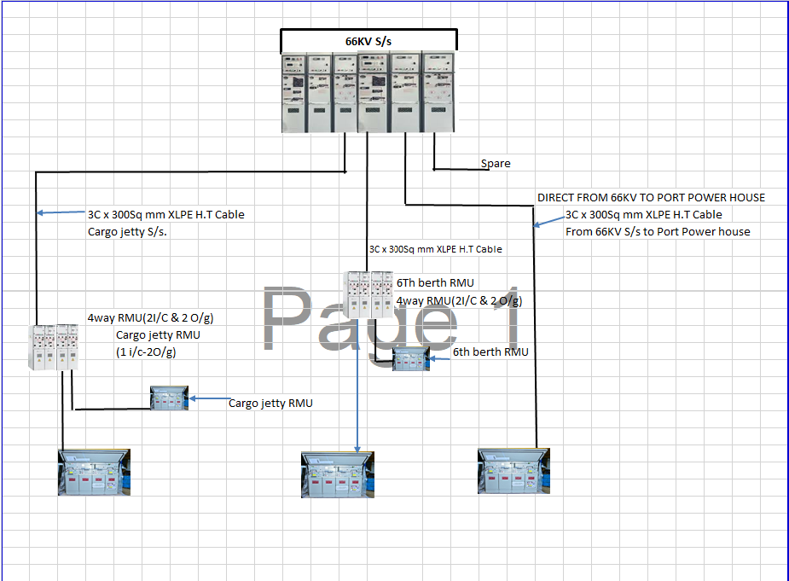
Fig 3
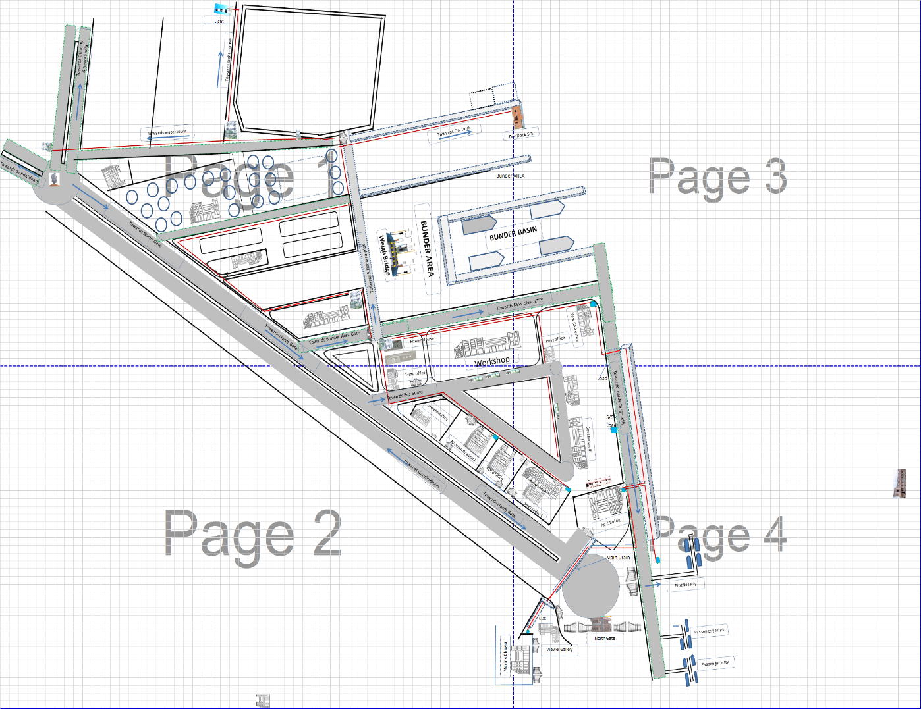
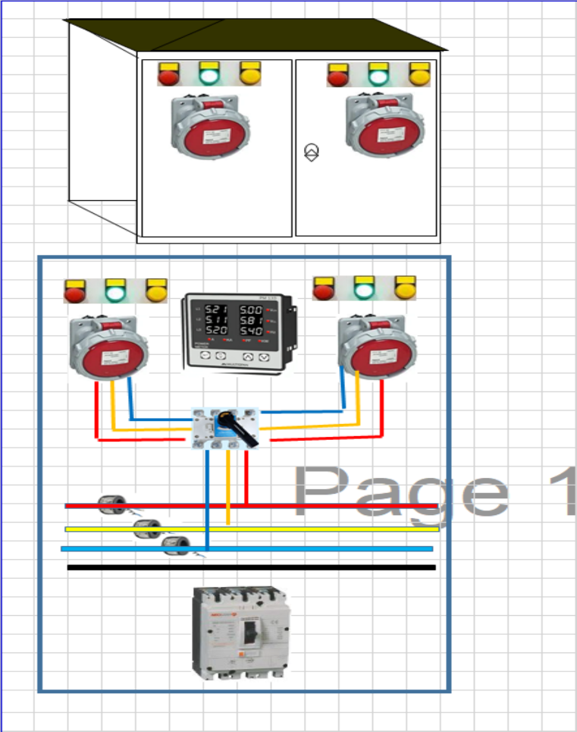
Power Plug Point Panel at SNA

---SD--
Signature & Seal of Contractor Executive Engineer (E)
Deendayal Port Trust

